Net 1061 Switching, Routing, and Wireless Essentials

Name:

Lab: #

Follow the instructions down below for the lab itself. For this lab, all answers need to be in blue font. For the questions right below, answer in complete sentences. If this is a self-grading packet tracer. Ensure you paste the screen shot of your score page at the bottom of the document. You will upload both this document and the pkt file regardless if it is self-grading or not. Let the instructor know if you have any questions.

Lab Analysis Report

1. Using complete sentences summarize work you completed during the lab.
In this lab, I created a network topology. Then, I cabled all the devices and configured the Router, Switches, and PCs to have connectivity. Finally, I verified connectivity between the devices.

2. Using complete sentences describe what you learned from the lab. Hint; look at the lab objectives listed at the top of the lab section.
In this lab, I learned how to take my skills and put them all together. I practiced how to configure devices to be able to connect with each other.

Problems Encountered

1. Using complete sentences describe any problem(s) experienced during lab.
I didn’t experience any problems.

2. Using complete sentences describe how you solved your problem(s).

3. Using complete sentences explain if you needed any assistance with the lab; then list what you learned from that assistance.

Packet Tracer - Implement a Small Network

Addressing Table
Device | Interface | Address | Subnet Mask | Default Gateway
RTA | G0/0 | 10.10.10.1 | 255.255.255.0 | N/A
RTA | G0/1 | 10.10.20.1 | 255.255.255.0 | N/A
SW1 | VLAN1 | 10.10.10.2 | 255.255.255.0 | blank
SW2 | VLAN1 | 10.10.20.2 | 255.255.255.0 | blank
PC-1 | NIC | blank | 255.255.255.0 | blank
PC-2 | NIC | blank | 255.255.255.0 | blank

Objectives
Part 1: Create the Network Topology
Part 2: Configure Devices and Verify Connectivity

Instructions

Create the Network Topology

Obtain the required devices.
      - Click the Network Devices icon in the bottom tool bar.
      - Click the router icon in the submenu.
      - Locate the 1941 router icon. Click and drag the icon for the 1941 router into the topology area.
      - Click the switch entry in the submenu.
      - Locate the 2960 switch icon. Click and drag the icon for the 2960 switch into the topology area.
      - Repeat the step above so that there are two 2960 switches in the topology area.
      - Click the End Devices icon.
      - Locate the PC icon. Drag two PCs to the topology area.
      - Arrange the devices into a layout that you can work with by clicking and dragging.

Name the devices.
The devices have default names that you will need to change. You will name the devices as shown in the Addressing Table. You are changing the display names of the devices. This is the text label that appears below each device. Your display names must match the information in the Addressing Table exactly. If a display name does not match, you will not be scored for your device configuration.
      - Click the device display name that is below the device icon. A text field should appear with a flashing insertion point. If the configuration window for the device appears, close it and try again, clicking a little further away from the device icon.
      - Replace the current display name with the appropriate display name from the Addressing Table.
      - Repeat until all devices are named.

Connect the devices.
      - Click the orange lightning bolt connections icon in the bottom toolbar.
      - Locate the Copper Straight-Through cable icon. It looks like a solid black diagonal line.
      - To connect the device, click the Copper Straight-Through cable icon and then click the first device that you want to connect. Select the correct port and then click the second device. Select the correct port and the devices will be connected.
      - Connect the devices as specified in the table below.
From Device | Port | To Device | Port
RTA | G0/0 | SW1 | G0/1
RTA | G0/1 | SW2 | G0/1
SW1 | F0/1 | PC-1 | Fastethernet0
SW2 | F0/1 | PC-2 | Fastethernet0

Configure Devices
Record the PC addressing and gateway addresses in the addressing table. You can use any available address in the network for PC-1 and PC-2.

Configure the router.
Open configuration window
      - Configure basic settings.
        - Hostname as shown in the Addressing Table.
        - Configure Ciscoenpa55 as the encrypted password.
        - Configure Ciscolinepa55 as the password on the lines.
        - All lines should accept connections.
        - Configure an appropriate message of the day banner.
      - Configure interface settings.
        - Addressing.
        - Descriptions on the interfaces.
        - Save your configuration.

Configure switch SW1 and SW2.
      - Configure the default management interface so that it will accept connections over the network from local and remote hosts. Use the values in the addressing table.
      - Configure an encrypted password using the value in step 1a above.
      - Configure all lines to accept connections using the password from step 1a above.
      - Configure the switches so that they can send data to hosts on remote networks.
      - Save your configuration.
Close configuration window

Configure the hosts.
Configure addressing on the hosts. If your configurations are complete, you should be able to ping all devices in the topology.
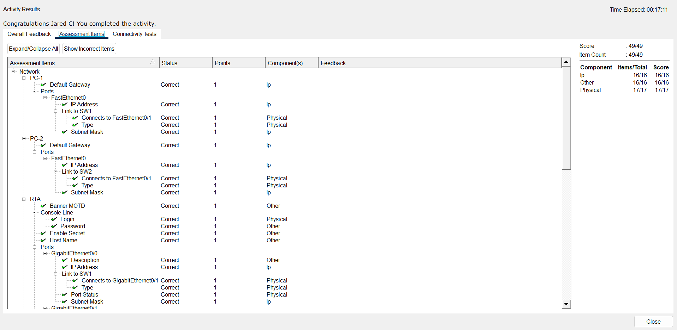
End of document

